**SAVING HEAT MAPS AND DOWNLOADING THE NG-CHM VIEWER APPLICATION SCENARIO OUTLINE**

1. Perhaps you have made some changes to the configuration of a heat map that you have opened. In this example, the user has made a modification to preferences for their heat map changing the dendrogram heights for the row and column axes:

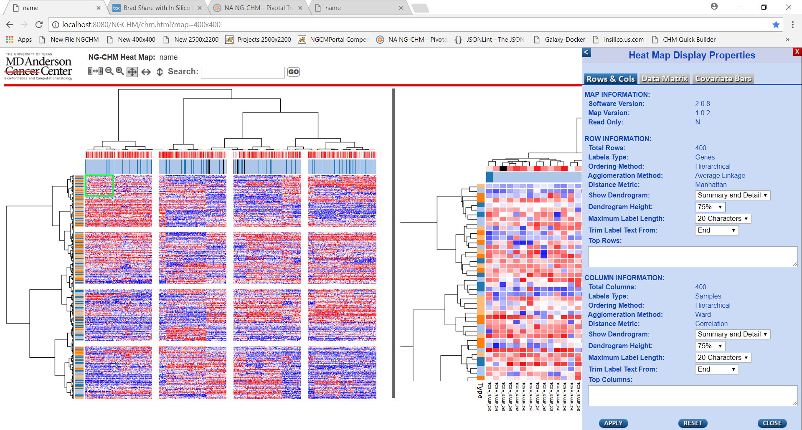

1. Begin the save process by pressing the “Save Heat Map Changes” button on the top right of the NG-CHM Viewer screen (provide arrow to button):

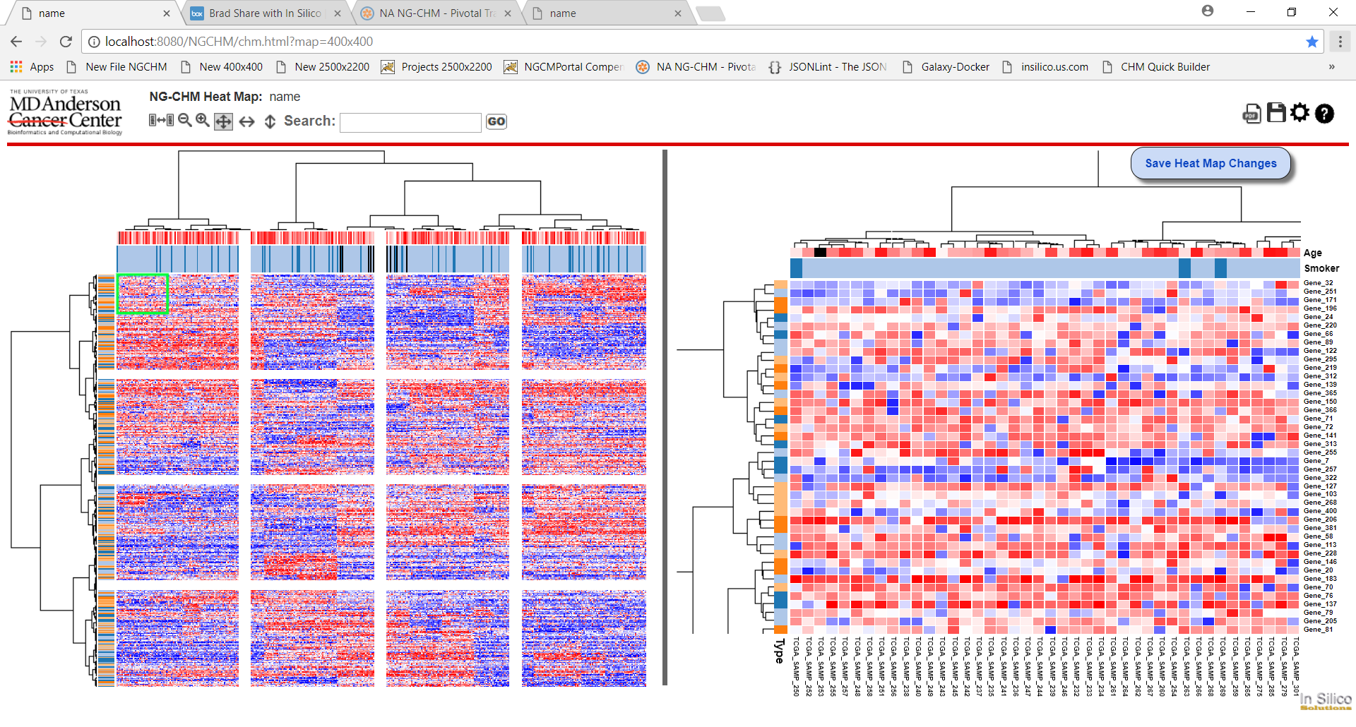

1. If such a change has been made to a map that is NOT read-only, the user may save the map to the server, from which it was opened, by pressing the “SAVE ORIGINAL” button. When this button is pressed, the preference changes that you have made to the heat map configuration will be saved to the server. When re-opened, the map will contain those changes (in this case, the changes to the dendrogram height): 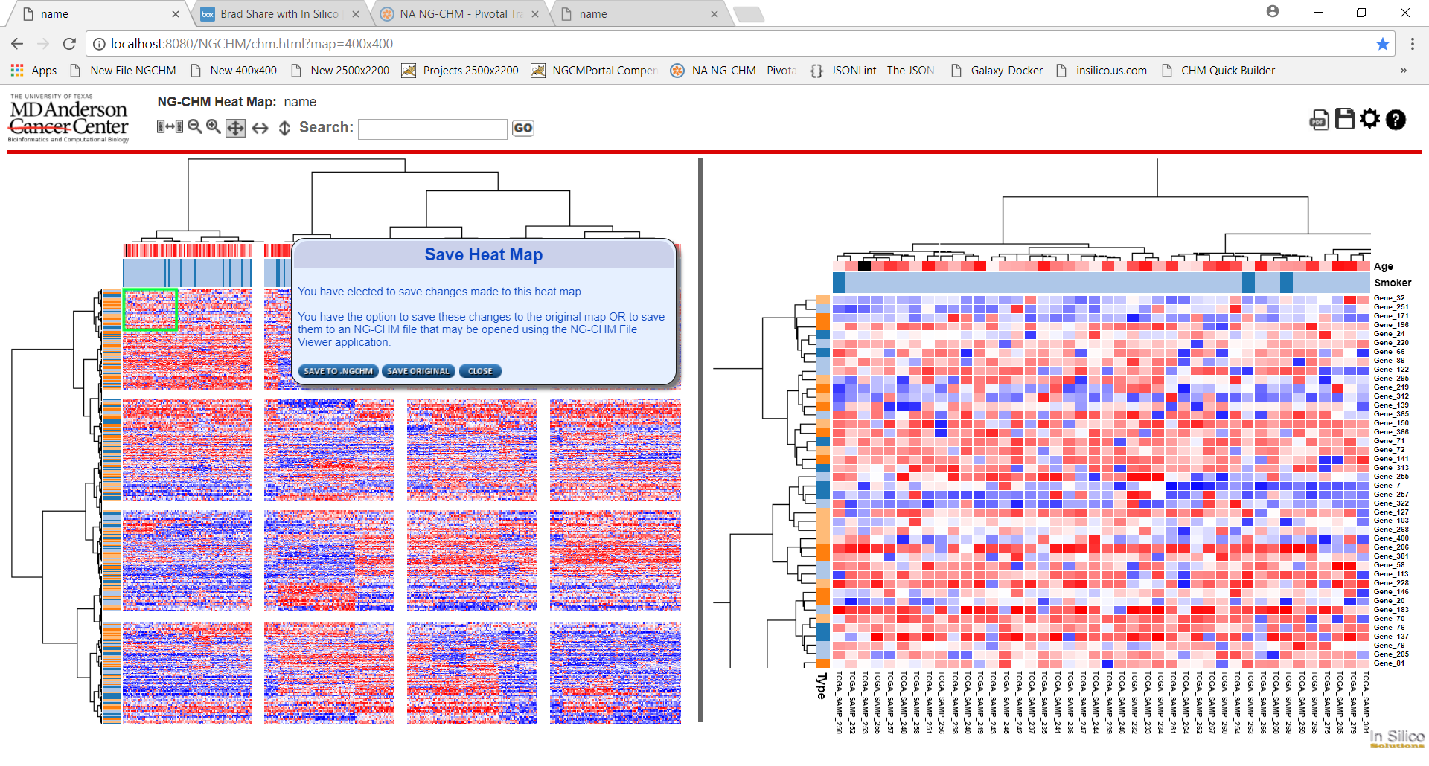
2. If no changes have been made to the heat map properties, the save original button will not appear on the save popup. In this case the user will still be provided with only the option to save the heat map to a local .NGCHM file:

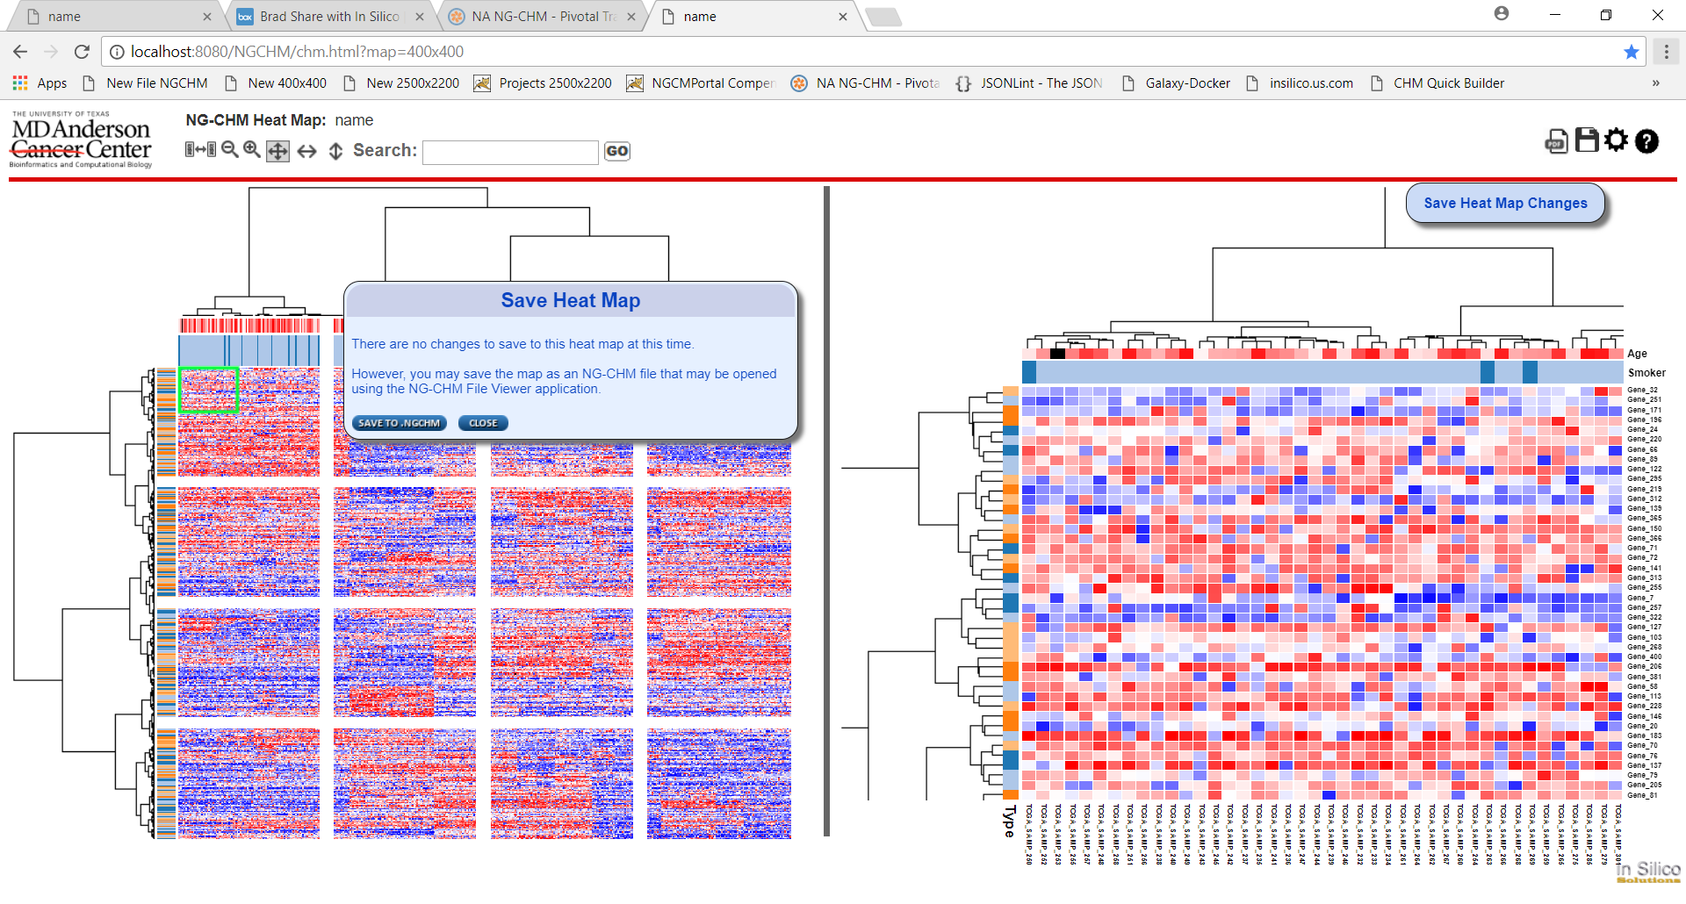

1. To save the heat map to a local .NGCHM file on your computer, press the “SAVE TO NGCHM” button. This will begin the process to download all of the files (data and configuration) necessary to view the heat map in the stand-alone NG-CHM Viewer Application as a file with the .NGCHM extension. Depending upon the browser that you are using (in this case, Google Chrome), you will see an indication of a successful download. You will also be presented with an opportunity to download the latest version of the NG-CHM Viewer Application. You will need this to view any .NGCHM file:

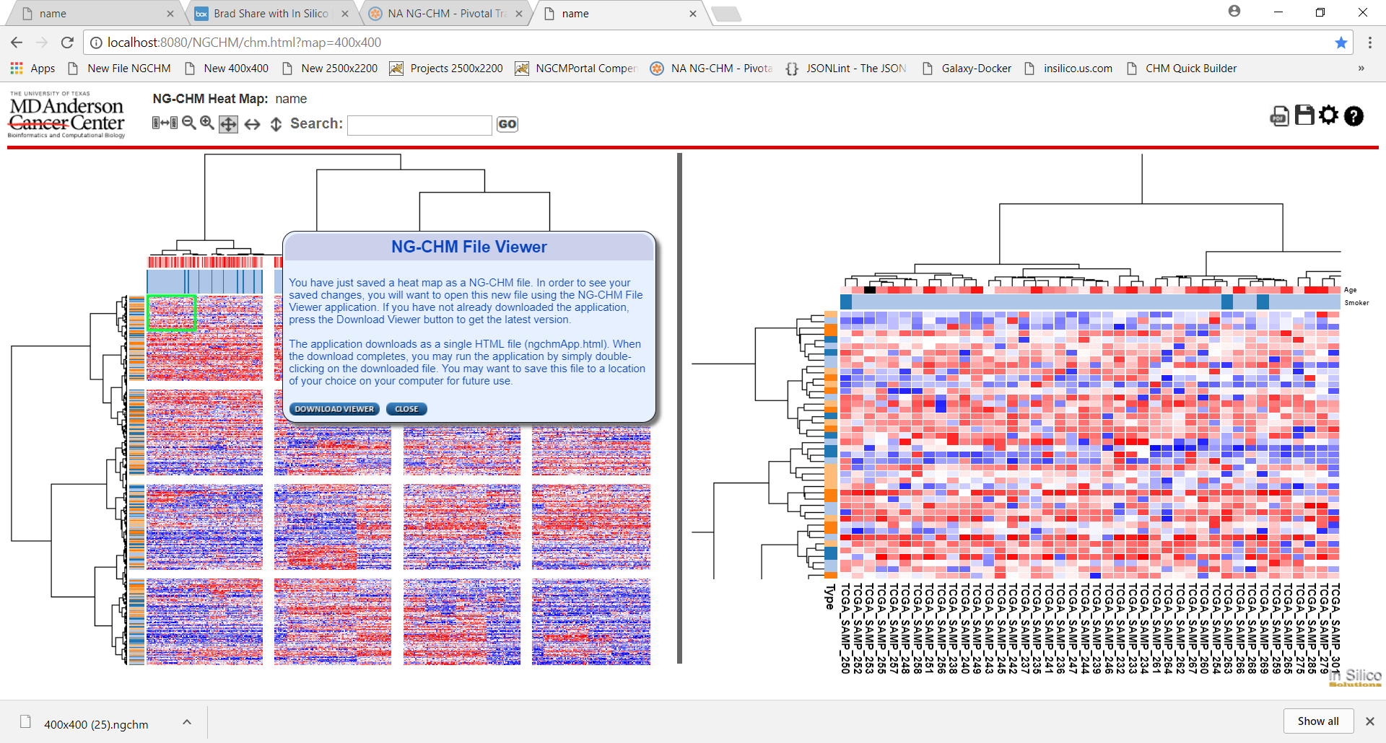

1. To download the latest version of the NG-CHM Application Viewer, just press the “DOWNLOAD VIEWER” button. The application will download as a single .HTML file. You will see in your browser that the download has been successful:

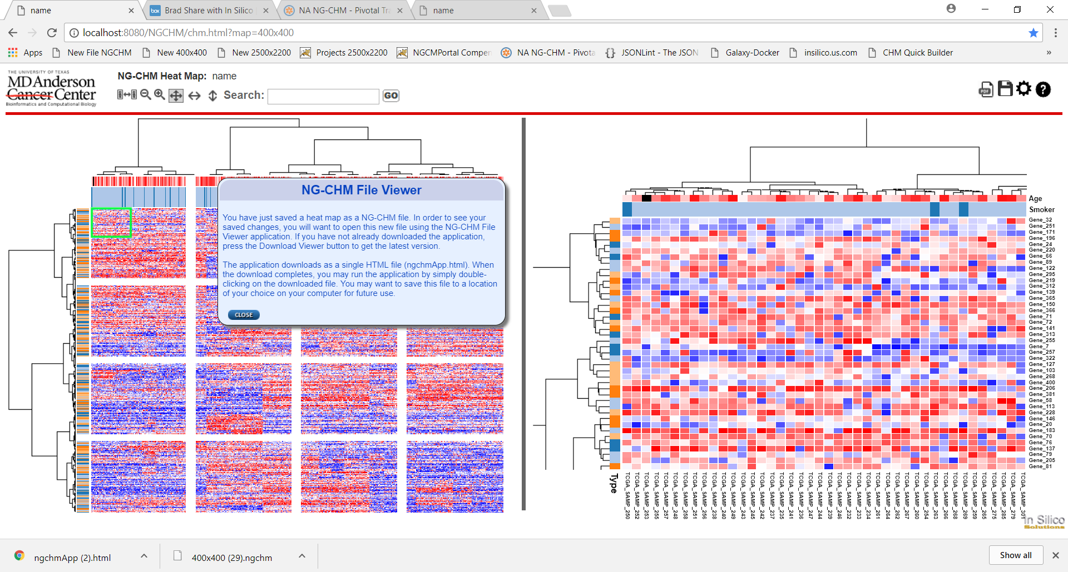

1. There is another way that the user will be offered a download of the NG-CHM Viewer Application. This occurs when the version of that application that the user has is older than the most current release of the software. In this case when the user opens a heat map in the viewer, they will be provided with an opportunity to download the latest version:

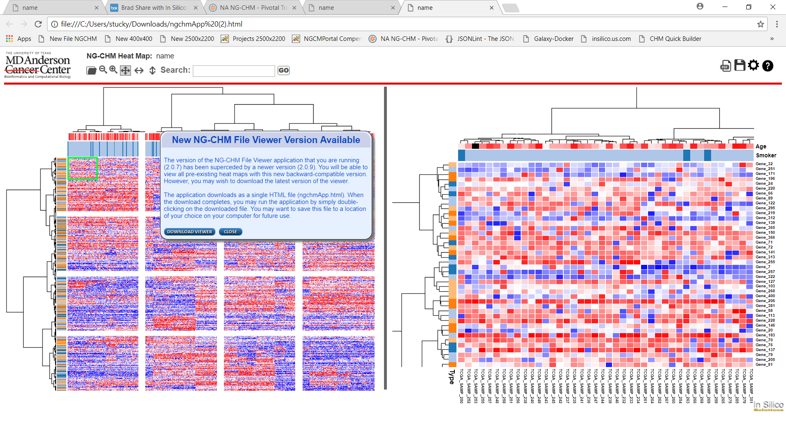

**RUNNING THE STAND ALONE NG-CHM VIEWER APPLICATION**

1. Once you have downloaded the stand alone NG-CHM Viewer Application contained in the ngchmApp.html file, you may run the application by simply clicking on the file (either from your browser or from the downloads directory on your machine). NOTE: You may wish to move the ngchmApp.html file to a directory of your choice on your work machine for future use.:

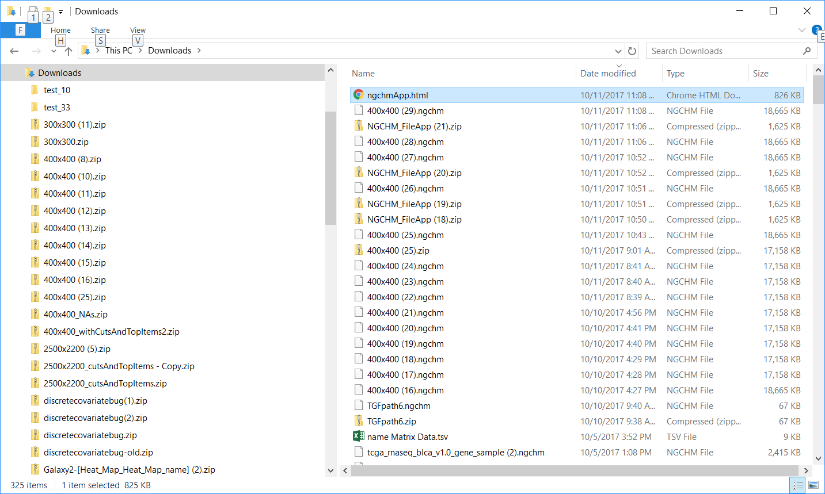

1. Once the application comes up in your browser you may open an NG-CHM Heat Map by pressing the “Choose File” button on the menu bar of the application:

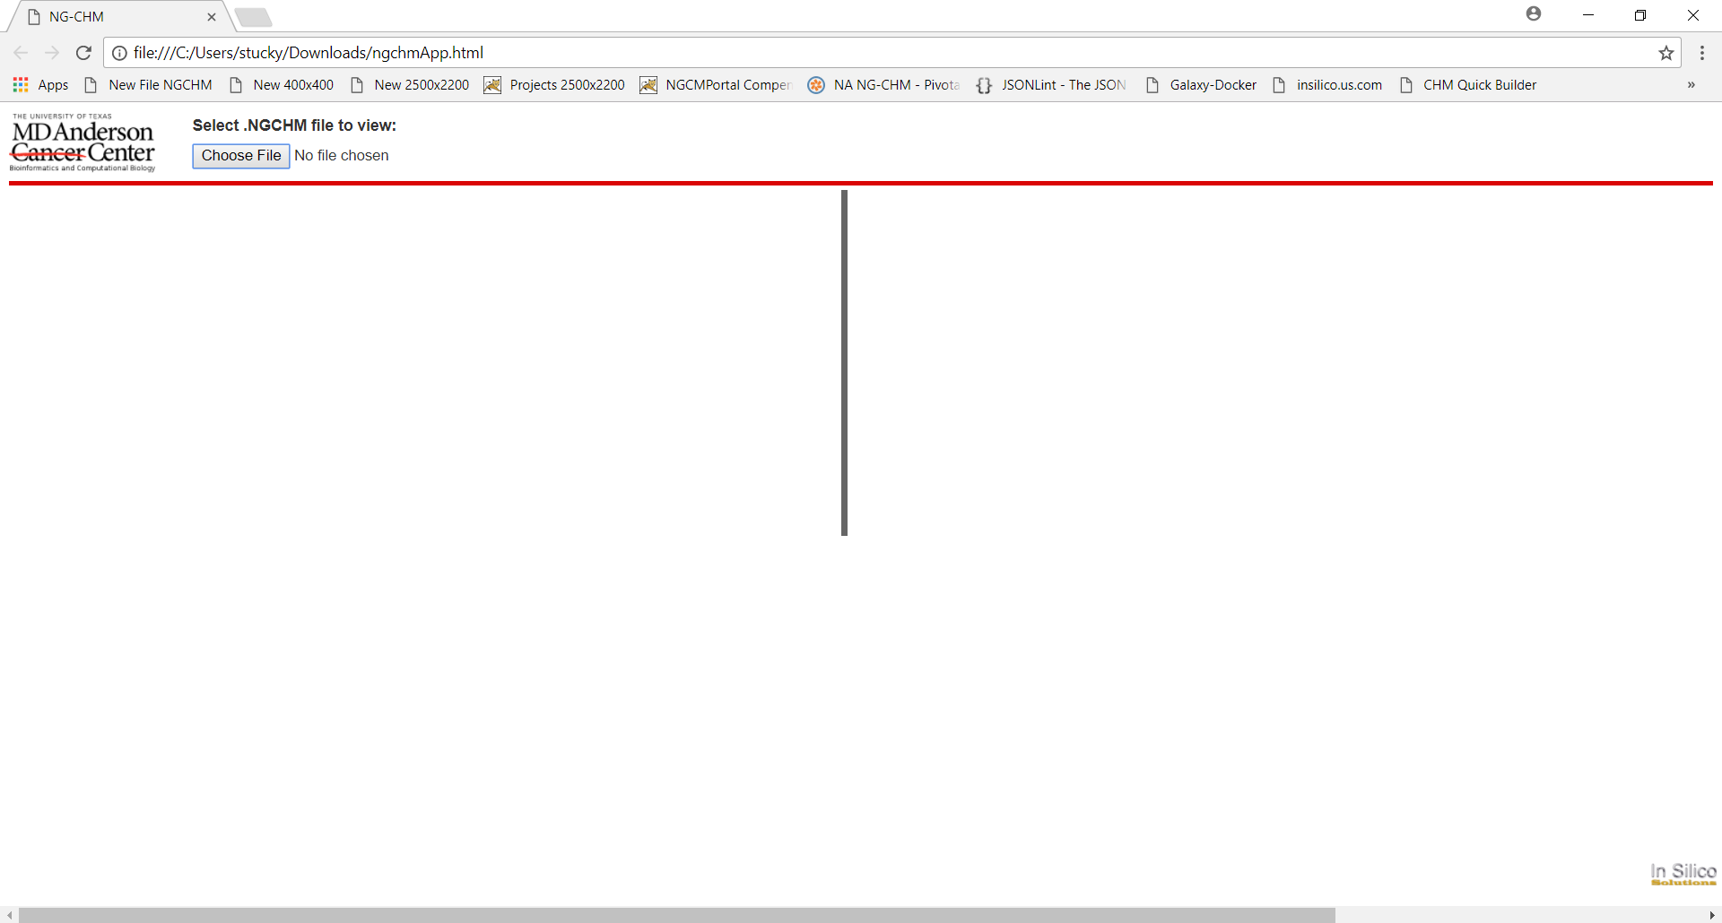

1. Select a .NGCHM file that you have downloaded to your machine to open that heat map:

